**TRANSPORTATION MULTI-TOOL UPDATE**

**Description:** Our program serves as a comprehensive traffic multitool designed specifically for processing Traffic Volume Count (TVC) data and Spot Speed Data. It streamlines the handling of traffic volume data by creating homogenized tables from raw inputs, facilitating efficient further analysis. Additionally, the program generates detailed overview reports of traffic volume and accepts, processes, and analyzes Spot Speed Data. Built with SQL queries, the results can be seamlessly transformed into Excel for easy access and interpretation.  
  
**Features:**

1. **Traffic Volume Data Processing**
   * Automatically processes raw Traffic Volume Count (TVC) data.
2. **Homogenized Data Table Creation**
   * Converts raw traffic data into a standardized, structured table for further analysis.
3. **Spot Speed Data Analysis**
   * Accepts and analyzes Spot Speed Data for detailed speed assessments.
4. **Comprehensive Traffic Overview Reports**
   * Generates summary reports for both traffic volume and speed data.
5. **SQL-Based Query System**
   * Leverages SQL queries for efficient data retrieval and processing.
6. **Excel Integration**
   * Transforms SQL results into Excel-compatible formats for user-friendly reporting and data manipulation.
7. **Multi-Format Export Options**
   * Provides flexible data export options for easy sharing and collaboration.
8. **Real-Time Data Analysis**
   * Offers capabilities for near real-time data processing and reporting (if applicable).
9. **Dashboard**
   * Generates a dashboard for an interactive report.

**UPDATE (16/10/2024)**

As of this report, the minimum viable product (MVP) of the program is fully operational, specifically in handling the Traffic Volume Count (TVC) processing component. While further development is required to implement the dashboard functionality, the current version is capable of managing core data processing tasks.

Attached is a list of key indicators and charts that will be incorporated into both the report and the future dashboard:

1. Vehicle Distribution
2. VPH (Vehicles Per Hour) Time Series by Hour
3. PCUH (Passenger Car Unit per Hour) Time Series by Hour
4. Maximum Level of Service (LOS) with Approach
5. Critical Hour Identification
6. VPH Time Series by Day
7. Average Count per Approach
8. Critical LOS from Critical Hour
9. Sum of Count by Day (in vehicle units)
10. Sum of Count by Day (in PCU)

For the Spot Speed Data report, further development is required to calculate and display percentile speed rankings to assess speed distribution. Additionally, the PCU table requires re-verification, which can be achieved by referencing journals from sources such as NCTS or DPWH.

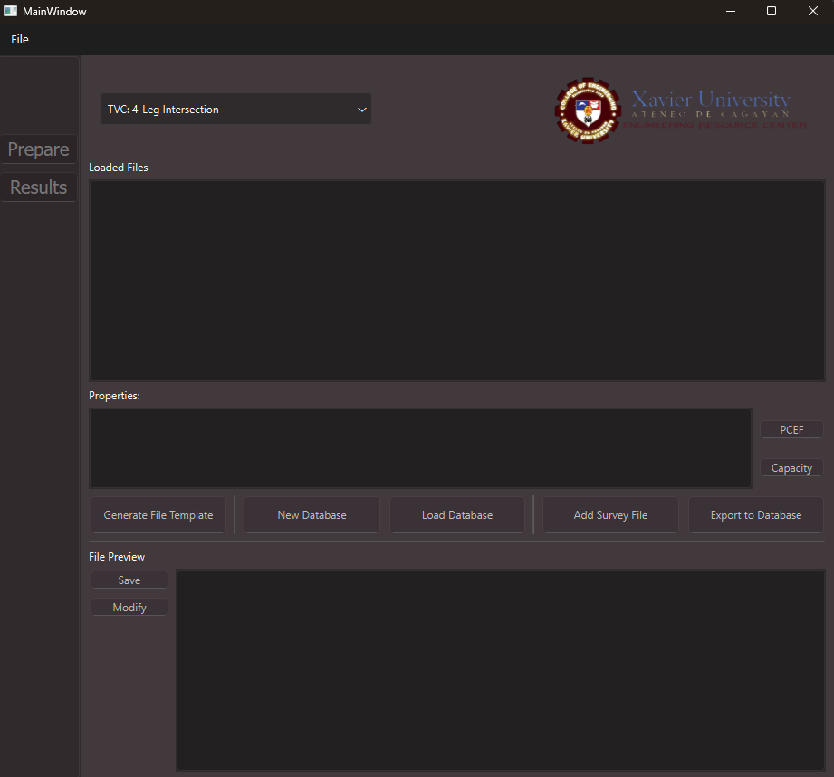

Figure Sample of Program's UI

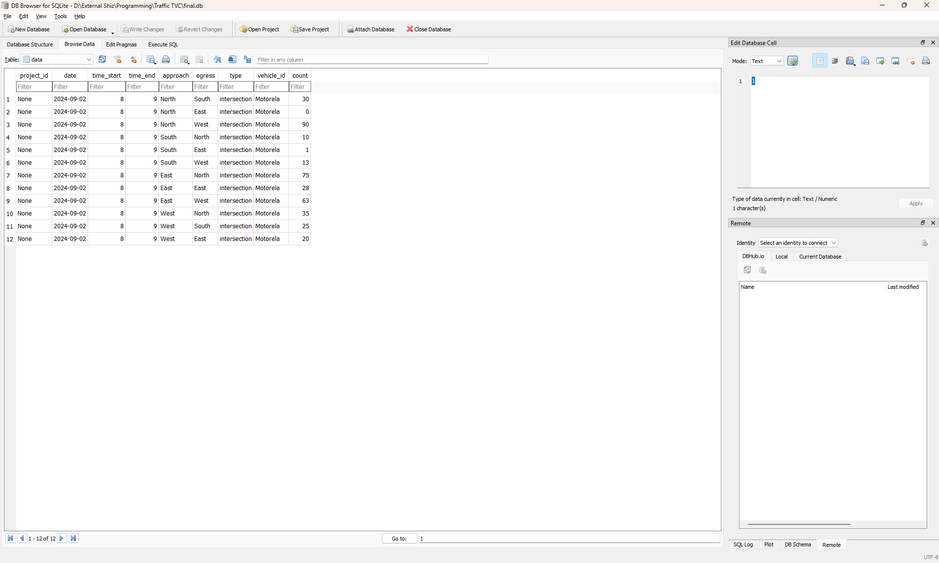

Figure Sample Data in Database